***School of Engineering & Information Technology***

**ICT290 COVER SHEET**

|  |  |  |  |  |
| --- | --- | --- | --- | --- |
| **Given Names** | **Surname** | **Student Numbers** | **Mode (D/X)** | **Email** |
| Vladislav | Kennebury | 33644189 | D | vkennebury88@gmail.com |
| Connor | Nicholson | 33021181 | D | nicho97@outlook.com |
| Charlie | Sewell | 33741265 | D | charliesewell@live.com |
|  |  |  |  |  |

**Name of tutor:** James Moodie **Day & Time of tutorial:** Monday 4:30PM

**Assignment Number:** 1 **Due Date:** 14/09/2020 **Date Submitted:** 14/09/2020

If the given name by which your tutor knows you differs from your name on university records, you should indicate both names above. Tutor’s name must be entered. Penalty is 10% of the total marks for the submission for not providing information asked for.

Your assignment should meet the following requirements. Please confirm this (by ticking boxes) before submitting your assignment that you have checked the declarations you need to make. ***Some items do not apply for online/electronic submission.***

Except where I have indicated, the work I am submitting is my own work for the purpose of this assessment and has not been submitted for assessment in another unit.

This submission complies with Murdoch University's academic integrity commitments. I am aware that information about plagiarism and associated penalties can be found at http://www.murdoch.edu.au/teach/plagiarism/. If I have any doubts or queries about this, I am further aware that I can contact my Unit Coordinator prior to submitting the assignment.

I acknowledge and agree that the assessor of this assignment may, for the purpose of assessing this assignment:

• Reproduce this assignment and provide a copy to another academic staff member; and/or

• Submit a copy of this assignment to a plagiarism-checking service. This web-based service will retain a copy of this work for the sole purpose of subsequent plagiarism checking, but has a legal agreement with the University that it will not share or reproduce it in any form.

I have retained a copy of all submitted work. Zip file submitted in LMS is retained by all whose names appear on this sheet.

I will retain a copy of the notification of receipt of this assignment. If you have not received a receipt within three days, please check with your Unit Coordinator.

Assignment is presented on A4 size paper and is neatly collated. (Internal students)

Assignment includes virus-free disk with machine-readable programs & files relevant only to this submission. CD or DVD only may be accepted. (Internal students)

Instructions relating to answering of questions, formats used for electronic submission and LMS submission have been followed.

* Writing is clearly legible or has been printed.
* Group work breakdown declaration sheet for group work projects has been completed and signed by all team members. (Internal students)
* Pages have been firmly stapled. (Internal students)

______________________________________________________________________________ *(all group members must sign*)

Internal signature(s) – sign in order of the names given above for submission via the assignment box.

For Submission in LMS: I am aware that I am making this declaration by submitting this document electronically and by using my Murdoch ID and password it is deemed equivalent to executing this declaration with my written signature.

**Assignment Name: ICT290 Assignment 1**

**Group Name: Team No Name 2**

|  |  |  |  |  |
| --- | --- | --- | --- | --- |
| **Member’s Names** | **Brief Description of Tasks** (if more space is needed, attach extra sheets) | **Member’s contribution to the total work (%)** | **Date signed** | **Signature** |
| Vladislav Kennebury | Modelling, texturing and implementing collision for stairs. |  | 14/09/2020 |  |
|  | Design and implementation of Portal class, as well as the display and texturing of two portals. |  | 14/09/2020 |  |
|  | Placement and re-orientation of courtyard textures. |  | 14/09/2020 |  |
|  | Small extension to 2nd floor courtyard balcony. |  | 14/09/2020 |  |
|  | Added collision to all courtyard pillars and extra objects (bins) | 33.33% | 14/09/2020 |  |
|  |  |  |  |  |
|  |  |  |  |  |
|  |  |  |  |  |
| Charlie Sewell | Implementation of PNG image loader as well as supporting functions in textured polygons. |  | 14/09/2020 |  |
|  | Update of both splash screens to our photos and names as well as updated user controls. |  | 14/09/2020 |  |
|  | Setup of github as well as git ignore file. as well as managing all merge conflicts |  | 14/09/2020 |  |
|  | Doxygen Documentation of all shays classes as well as as textured polygons |  | 14/09/2020 |  |
|  | Video of working program | 33.33% | 14/09/2020 |  |
|  |  |  |  |  |
|  |  |  |  |  |
|  |  |  |  |  |
| Connor Nicholsn | Changed the camera system to allow all direction movement with the mouse, and key buffering with the keyboard to allow pressing 2 buttons keys at once. |  |  |  |
|  | Modeled the base structure of the extension area and the new world. |  |  |  |
|  | Moved the display functions of shays world into a class and implemented the switching of displays by calling the corresponding world object. | 33.33% | 14/09/2020 |  |
| ***Total percentage*** *(should total to 100% if all work is completed)* |  | 100% | 14/09/2020 |  |

**Instructions:**

Please complete the information as specified above. It should list each group member’s percentage contribution to the submitted work. *For example if there are 4 members and they all make equal contributions to the total work, then each gets 25%*. This statement needs to be signed by all group members to indicate their agreement to percentage breakdown.

The purpose of this declaration is to provide documentary evidence of each group member’s contribution to the submitted work. This was demonstrated during the lecture in Week 2 of the semester. Please present this sheet after the printed and completed unit cover sheet.

Individual accounting spreadsheet should also be completed and can be submitted with the project. The self and peer assessment form should be completed and submitted separately.

## Table of Contents

**Table of Contents** **3**

**Design and Planning** **4**

**Issues** **5**

**Maintenance Issues** **5**

**Special Features** **5**

**Testing Details** **5**

**Suggestion for Improvement** **7**

**How is code reuse taken care of?** **7**

**Can the assets/objects/items be reused easily in other programs?** **7**

## 

## Design and Planning

Design involved gathering photos of the real life courtyard on the Murdoch campus, which allowed us to accurately place specific textures and scale within the world. This was especially important for the shape, look and orientation of the stairs. Furthermore, the collection of specific images allowed for the use of new textures within the space.

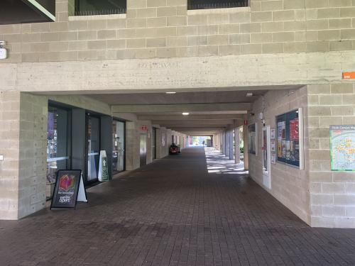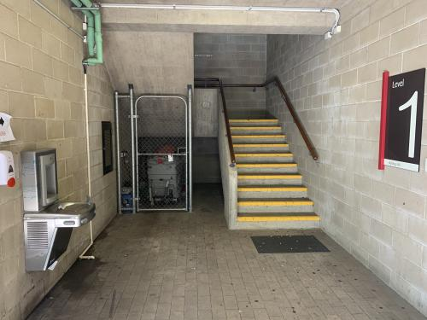

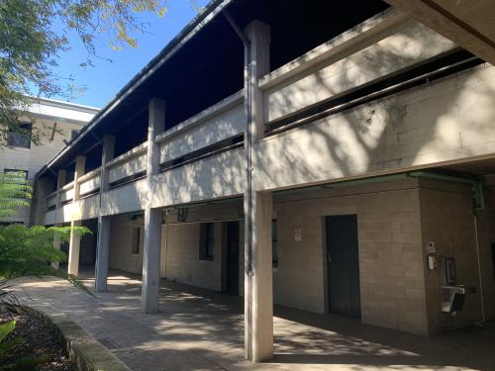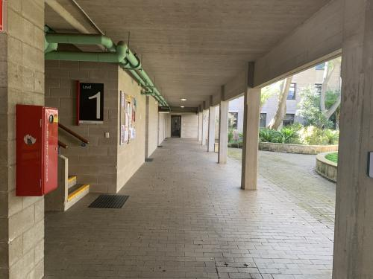

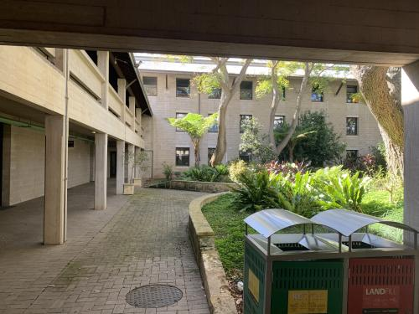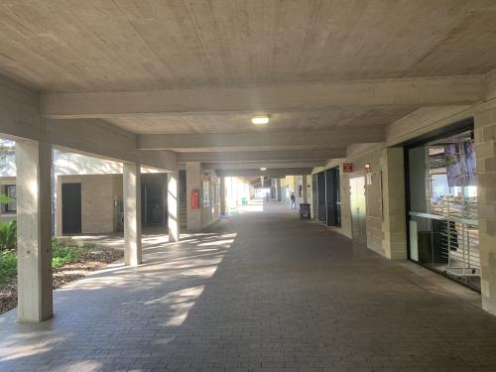

Main design choices were made with the bush court extensions, however a few ideas based around the theme of a digital and futuristic environment allows us to explore and create the environment of the gameworld, in space. Sci-fi elements including the use of portals were incorporated, with plans to expand upon the idea in Assignment 2.

## Issues

|  |  |
| --- | --- |
| **Issues encountered** | **How it was resolved** |
| Texture Orientation | Manual change of vertex corners depending upon the axis that the image is on. Used for flipping or rotating certain textures. |
| Sudden plain changes | Interference through the collision between multiple plains, as well as the aid of bounding boxes surrounding certain components allowed the player to be restricted from entering specific areas. |
| Player wouldn’t move if you tried to strafe left or right quickly | Changed the input system to implement key buffering to allow the process of multiple keys at once |
| Could not convert .raw files either to or from another format | We implemented a png loader to add our additional images and textures. |

## Maintenance Issues

We had huge issues with github and merging branches. This was mainly as a result of the auto generated files that visual studio makes/changes when anything is changed in a project. These files can't be merged as they are mostly binary so we had to include a .gitignore to try and minimise the amount of conflicts. However it isn’t perfect and we are still working on our workflow.

We also had a hard time maintaining doxygen comments as we had to find out what each of shays functions did in order to correctly document it which turned into a hassle.

## Special Features

* The camera is implemented as a traditional 3D FPS camera, where mouse movements alter the view of the player, without the need for key presses or holding down mouse buttons.
* The key presses are implemented using key buffering so the player is able to press multiple keys at once (eg quick alternate strafing and diagonal movement.
* Each world has its own display function so using a boolean value in the main display loop allows the seamless switching between worlds.
* Portals are implemented as a form of traversal through a world, as well as between Shay and Wrath, this allows multiple uses with level design which can be expanded upon.

## Testing Details

Testing for Wrath involved checks for various components of the code, which included:

|  |  |  |  |  |  |
| --- | --- | --- | --- | --- | --- |
| **Test Number** | **Description / Justification** | **Input** | **Expected Output** | **Actual Output** | **Success/Fail** |
| 1 | Movement - Check to make sure the player movement works as intended with strafing and forward/back | WASD | Correct directional input  (W = Up)  (A = Left)  (S = Down)  (D = Right) | (W = Up)  (A = Left)  (S = Down)  (D = Right) | Pass |
| 2 | Camera Look - Check to make sure changes in the input from the mouse allow the player to look around the world. | Mouse | Correct directional change  (Mouse Up = Up)  (Mouse Down = Down)  (Mouse Left = Left)  (Mouse Right = Right) | (Mouse Up = Up)  (Mouse Down = Down)  (Mouse Left = Left)  (Mouse Right = Right) | Pass |
| 3 | Welcome Screen - Checks to make sure that the welcome splash screen appears with the correct controls. | Space | Welcome screen shows up after ‘space’ is entered | Welcome screen is displayed | Pass |
| 4 | Stairs Collision - Checks to make sure the player ascends and descends the stairs properly, with railing bounds. | WASD | Correct change in y axis when ascending or descending. | Correct change in y axis when ascending or descending. | Pass |
| 5 | Portal Collision - Checks to make sure that the player position is changed after collisions with the portal. | WASD | Correct change in player location to set destination. | Correct change in player location to set destination. | Pass |
| 6 | Collision Boxes - Checks that the player is stopped when colliding with bounding boxes for objects such as pillars and bins. | WASD | Halts the player when collision between a bounding box occurs. | Halts the player when collision between a bounding box occurs. | Pass |
| 7 | Change of Displays - Checks to verify that display functions for rendering Shay’s and the gameworld are changed when called. | WASD | Shay’s world stops being rendered, while textures for Wrath world are displayed. | Shay’s world stops being rendered, while textures for Wrath world are displayed. | Pass |
| 8 | Exit Screen - Screen appears after ESC is pressed on the splash screen, and the game closes after mouse click is pressed. | ESC, Mouse | Exit splash screen appears and game exits when mouse click is used on the screen. | Exit splash screen appears and game exits when mouse click is used on the screen. | Pass |
| 9 | Stairs Return Portal - Checks that the display changes when returning from the game world to Shay’s, in the correct position. | WASD | Return the player to Shay’s world and correct position in front of stairs. | Return the player to Shay’s world and correct position in front of stairs. | Pass |
| 10 | Special Portal - Checks that portal functions as a change in location, instead of being linked to transition between worlds/displays. | WASD | Player location changes to set destination in Shay’s world. | Player location changes to set destination in Shay’s world. | Pass |

Tests for the code were made throughout the development process, in particular in areas that needed to be fine tuned for accuracy, such as the location of portal collision and fixes to camera direction.

## Suggestion for Improvement

* Need to overload the camera class assignment operator to allow reassignment of camera values to streamline the calling of main functions.
* Rewrite the linked list system into something more intuitive and optimised.
* Write destructors for respective world classes to destroy objects and clear memory when switching to a new world. Display switch is currently very inefficient.
* Fix a bug where the player spawns staring at the sky.
* Fix a bug where the player has to hit space after first teleport to gain movement control.
* Fix a bug where some textures in the courtyard do not display properly.
* Texture rendering issues at distance (However same issue is present in Shays world, STA travel sign next to computer labs)

## How is code reuse taken care of?

We have reused as much of shays code as we can making small changes to clean stuff up and optimise it. Heading forward we will begin to optimise it more which will involve rewriting sections that we dont believe to be efficient.

## Can the assets/objects/items be reused easily in other programs?

To a small extent, assets can be used within other programs, in regards to the PNG and RAW files. However, due to no object loader being implemented at this stage the programs will require their own image loaders for accessing the PNG and RAW images.

## 